The Noble Marine Rooster

RS200 National Championship 2023

07 – 11 August 2023

East Lothian Yacht Club, Scotland, UK

SAILING INSTRUCTIONS
The notation ‘[NP]’ in a rule of the sailing instructions (SIs) means that a boat may not protest another boat for breaking that rule. This changes RRS 60.1(a).
The notation ‘[DP]’ in a rule in the SI means that the penalty for a breach of that rule may, at the discretion of the protest committee, be less than disqualification.

- RULES
  - The regatta will be governed by the rules as defined in The Racing Rules of Sailing.
  - When a gate start is used, RRS 29.1 is deleted; Individual Recall shall not apply.
- COMMUNICATIONS WITH COMPETITORS
  - Notices to competitors will be posted on the online official notice board at:
https://elyc.org.uk/rs200
  - Signals made ashore will be displayed from the dinghy park flag pole on Elcho Green.
  - [DP][NP] Boats shall not leave the shore until flag D is displayed ashore. The warning signal will be made not less than 30 minutes after flag D is displayed.
  - Any change to the schedule of races will be posted by 19:00 on the day before it will take effect and any change to the sailing instructions will be posted at least 30 minutes before flag D is displayed (SI 2.3) on the day it will take effect.
  - [DP][NP] While racing, except in an emergency, a boat shall not make voice or data transmissions and shall not receive voice or data communication that is not available to all boats.
  - The class flag will be the class insignia on a yellow background.
- SCHEDULE OF RACES
  - The race schedule is as follows:
Date: | Time of 1st warning signal & scheduled races per day:
 | Time: | # Races:
Mon 7th Aug | 13:00 | 2
Tues 8th Aug | 13:00 | 2
Wed 9th Aug | 13:00 | 2
Thur 10th Aug | 13:00 | 2
Fri 11th Aug | 11:00 | 2
  - The warning signal for each succeeding race will be made as soon as practicable.
  - To alert boats that a race will begin soon, flag G will be displayed on the race committee signal boat with one sound at least two minutes before a warning signal is made.
  - On the last day of the regatta no warning signal will be made after 15:00.
- RACING AREAS
  - See NOR 9.1
- THE COURSES
  - The diagram in Attachment A shows the courses, the course designations, the approximate angles between legs, the order in which marks are to be passed, and the side on which each mark is to be left.
  - The gate 2S-2P may be replaced by a single mark to be left to port.
  - No later than the warning signal, the race committee signal boat will display the course designation and the approximate compass bearing of the first leg.
  - To change the next leg of the course, the race committee will move the original mark (or the finishing line) to a new position.
- MARKS
  - Marks 1, 2P, 2S will be inflated orange cylindrical buoys. Mark 1a will be yellow spherical buoy.
  - Starting marks will be the port limit mark (a buoy with an orange flag laid close to the signal vessel), the pathfinder (until released) and the gate launch (displaying flag G).
  - Finishing marks will be a race committee boat and a boat or buoy with a blue flag.
- THE START
  - Gate starts will be used.
  - Starting Area: The committee boat will be in the starting area, which will be to leeward of the course (Attachment B). The port limit mark will be laid at the leeward end of the gate.
  - Distinguishing Flags & Signals: The committee boat and gate launch will display flag G. The starting signals will be made from the committee boat.
  - Selection of Pathfinder: The race committee will nominate the pathfinder and a reserve pathfinder for the first race. Subsequently, the pathfinder will be the tenth boat in the preceding race. When she is unable to race, or has been the pathfinder previously in the event, the pathfinder will be the eleventh boat in the preceding race and so on. The reserve pathfinder will be the next boat in the previous race. The sail numbers of pathfinder and reserve for the first race of each day will be posted on the official notice board, and will be displayed on the side of the committee boat at least five minutes before the warning signal for the first race. If more than one race is sailed on the same day, the numbers will be displayed on the side of the committee boat at least five minutes before the warning signal for each successive race. The pathfinder and reserve shall report to the committee boat as soon as possible after her number is displayed and before the preparatory signal. A pathfinder or reserve that fails to report will be scored Did Not Start without a hearing. This changes RRS A5.1 and A5.2.
  - Positioning of Pathfinder and Gate Launch: At or up to 15 seconds before the starting signal the pathfinder shall commence her close-hauled port tack from within one boat length of the port limit mark, leaving the mark to port, followed by the gate launch which will keep close astern of her. If the pathfinder is unable to do this, the race committee will signal a general recall.
  - Starting Line: The starting line for all boats except the pathfinder will be between the port limit mark and the centre of the stern of the gate launch.
  - Pathfinder Course: The approximate time that the gate launch will be in motion along the port tack course after the starting signal will be displayed on the starboard side of the committee boat before the warning signal. The pathfinder shall maintain her close-hauled course until she is released by a hail from the gate launch, and may tack onto starboard. After releasing the pathfinder, the gate launch will maintain its course and speed. At the end of the period of time displayed on the committee boat (which may be extended at the discretion of the race committee) the gate launch will stop, lower flag G half way with a sound, and drift for at least one minute. Flag G will then be fully lowered with a sound to indicate the closing of the gate. No boat shall start after the gate start line is closed.
  - Starting: Boats other than the Pathfinder shall start by crossing the starting line on starboard tack after the starting signal and before the gate closes.
  - A boat that has not already started correctly, and that is on the course side of the gate launch while the gate is open, shall not cross the starting line from the course side.
  - Interference with Pathfinder and Gate Launch: After the preparatory signal, a boat shall not threaten the unobstructed sailing of the pathfinder, and shall not interfere with or try to pass between the pathfinder and the gate launch, or cause another boat to interfere in these ways.
  - If a boat infringes instructions 7.9 or 7.10 and is identified, she will be disqualified without a hearing, even if the race is restarted, re-sailed, or rescheduled. If a general recall is signalled or the race is abandoned after the starting signal, the race committee will display her sail number before the next warning signal for that race, and if the race is restarted or resailed, she shall not sail in it. If she does so her disqualification will not be excluded in calculating her series score. This changes RRS 36, 63.1 and A5.
  - A boat that cannot avoid touching a starting mark may hail a right-of-way boat for room and shall retire.
- THE FINISH
  - The finishing line will be between the mast displaying a blue flag on the finishing vessel and the finishing mark displaying a blue flag.
  - The race committee may award a finishing place to a boat by pointing flag W at her with a sound. The signalled boat shall be deemed to have finished, and the score awarded shall be the position she occupied at the time of the signal. If two or more overlapped boats are signalled, they shall be scored as if they were tied. This changes RRS 28.1 and A3.
- TIME LIMITS & TARGET TIMES
  - The time limit and target time in minutes is as follows:
Time limit | Target time | Finishing window
75 | 50 | 20
  - The Finishing Window is the time for boats to finish after the first boat sails the course and finishes. Boats failing to finish within the Finishing Window, will be scored DNF without a hearing. This changes RRS 35, A5.1 and A5.2.
  - Failure to meet the Target Time will not be grounds for redress. This changes RRS 62.1(a).
- HEARING REQUESTS
  - The protest time limit is 60 minutes after the last boat finishes the last race of the day or the race committee signals no more racing today, whichever is later. The time will available from the beachmaster.
  - Hearing request forms are available in the gazebo in the dinghy park.
  - Notices will be posted no later than 30 minutes after the protest time limit to inform competitors of hearings in which they are parties or named as witnesses, and the location where hearings will take place.
  - Post-Race Penalty:
    - A boat that may have broken a rule of Part 2, or RRS 31 or 42, may, after finishing the race concerned and before the start of a related protest hearing, notify the race committee that she accepts a 30% scoring penalty as stated in RRS 44.3(c), except that the minimum penalty is two places if that does not result in a score worse than DNF. This penalty does not reverse an OCS score, a disqualification under RRS 30.3 or 30.4. It is not available for a breach of RRS 2 or of class rules or for gross misconduct under RRS 69. Nor is it available to a boat that caused injury or serious damage, or gained a significant advantage by her breach: in these circumstances, her penalty is to retire.
    - When the penalty is accepted: (i) neither the boat nor the protest committee may then revoke or remove the penalty. (ii) the boat shall not be penalized further in a protest hearing when the protest committee decides that it was appropriate to the facts found and the applicable rules.
  - Advisory Meeting:
    - When there is an incident that will not result in the lodging of a protest or a request for redress, a boat may request an advisory meeting and notify any boat involved in the incident.
    - An adviser will then call a meeting to learn what may have happened and will state whether any rule appears to have been broken, and by which boat.
    - A boat may as a result notify the race office that it accepts a Post-Race Penalty when it applies to the incident, or choose to retire, but is not required to do so.
  - RYA Arbitration:
    - When a protest is lodged, a boat may at the same time request RYA Arbitration, or the protest committee or race committee may offer it.
    - If the parties and a member of the protest or race committee agree that RYA Arbitration is suitable, an arbitrator (who may be that member of the protest committee) will call an Arbitration Hearing. When it is the arbitrator’s opinion that a boat that is a party to the arbitration hearing has broken a rule for which the Post-Race Penalty is available, the party will be invited to accept that penalty and, if accepted, the protesting boat will be allowed to withdraw the protest.
    - When there is no agreement to use RYA Arbitration or when, after RYA Arbitration, a protest is not withdrawn or the Post-Race Penalty is not applicable to the facts, there will be a normal protest hearing at which the arbitrator may be a member of the protest committee. RRS 66 and 70 (reopening and appeal, respectively) do not apply to an arbitration since this is not a protest committee decision or procedure. A boat may still accept a Post-Race Penalty at any time before the start of a protest hearing and receive its protection from further penalty, or she may retire.
- SCORING
  - Two races are required to be completed to constitute a series.
(a) When fewer than four races have been completed, a boat’s series score will be the total of her race scores.
    - When from four to seven races have been completed, a boat’s series score will be the total of her race scores excluding her worst score.
    - When eight or more races have been completed, a boat’s series score will be the total of her race scores excluding her two worst scores.
  - To request correction of an alleged error in posted race or series results, a boat may complete a scoring enquiry form available from the gazebo in the dinghy park.
- SAFETY REGULATIONS
  - [DP] RRS 40.1 (Personal Flotation Devices) shall apply at all times while afloat.
  - Check-out and check-in of competitors will apply as follows:
Tally number tags must be firmly attached to boat trolleys of all competitor boats. This is a vital safety measure. Boats which fail to attach a tally to their trolly will receive a discretionary penalty.
  - [DP][NP] A boat that retires from a race, or does not intend to start a race, shall notify the race committee before leaving the race area.
  - [DP][NP] Boats shall return to and remain in their assigned berths whilst ashore.
- REPLACEMENT OF CREW OR EQUIPMENT
  - [DP] Substitution of competitors is not allowed without prior written approval of the race committee.
  - [DP] Substitution of damaged or lost equipment is not allowed unless authorized in writing by the race committee. Requests for substitution shall be made to the committee at the first reasonable opportunity, which may be after the race
- EQUIPMENT & MEASUREMENT CHECKS
A boat or equipment may be inspected at any time for compliance with the class rules, notice of race and sailing instructions.
- SUPPORT TEAMS
[DP] No support boats will be permitted at this event.

Attachment A

COURSE DIAGRAM

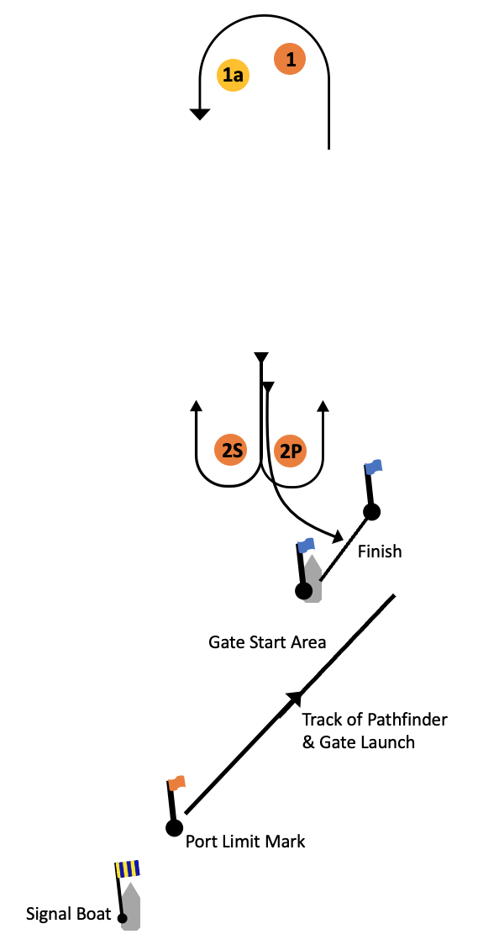
Course L: Windward/Leeward Course with Gate Start
Signal: | Mark rounding order:
L2 | Start – 1 – 1a – 2S/2P – 1 – 1a – 2P – Finish
L3 | Start – 1 – 1a – 2S/2P – 1 – 1a – 2S/2P – 1 – 1a – 2P – Finish

